Google Apps Script Automation
Objective:
Students will create an automation using Google Apps Script to improve productivity using Google Workspace tools.
Requirements: Use at least one Google Workspace service. Create an automation workflow. Use triggers if needed.
Document setup and usage. Handle errors properly. Deliverables: Apps Script code Project explanation Demo screenshots or video
Google Apps Script Project Ideas:
1 Send emails to multiple people using data from Google Sheets
2 Scan Gmail inbox and detect job rejection emails
3 Track job applications using Gmail + Google Sheets
4 Automatic reminder emails from Sheets
5 Google Form response summarizer
6 Create calendar events automatically from spreadsheet data

Use this project: Track Job Applications using Gmail + Google Sheets
It meets the assignment because it uses GmailApp, SpreadsheetApp, automation workflow, error handling, and a time-driven trigger. Google Apps Script supports Gmail access through GmailApp and Sheets access through SpreadsheetApp; time-driven triggers can run scripts automatically on a schedule.
Project Explanation
This automation scans Gmail for job application-related emails, detects possible rejection emails using keywords, and records the result in Google Sheets. It helps job seekers track applications, company responses, and rejection status automatically.
Google Sheet Columns
Create a sheet named Job Tracker with these headers:
Date | Sender | Subject | Status | Email Link | Notes
Apps Script Code
function scanJobEmails() {
try {
const sheet = SpreadsheetApp.getActiveSpreadsheet().getSheetByName("Job Tracker");
if (!sheet) {
throw new Error("Sheet named 'Job Tracker' not found.");
}
const searchQuery = '(subject:job OR subject:application OR subject:interview OR subject:role) newer_than:30d';
const threads = GmailApp.search(searchQuery, 0, 20);
const rejectionKeywords = [
"unfortunately",
"not successful",
"not selected",
"other candidates",
"decided not to proceed",
"will not be progressing",
"regret to inform"
];
const existingSubjects = sheet.getRange(2, 3, Math.max(sheet.getLastRow() - 1, 1), 1)
.getValues()
.flat();
threads.forEach(thread => {
const messages = thread.getMessages();
const message = messages[messages.length - 1];
const subject = message.getSubject();
const body = message.getPlainBody().toLowerCase();
const sender = message.getFrom();
const date = message.getDate();
if (existingSubjects.includes(subject)) {
return;
}
let status = "Application / Job Email";
for (let keyword of rejectionKeywords) {
if (body.includes(keyword)) {
status = "Possible Rejection";
break;
}
}
const emailLink = "https://mail.google.com/mail/u/0/#inbox/" + thread.getId();
sheet.appendRow([
date,
sender,
subject,
status,
emailLink,
"Automatically scanned from Gmail"
]);
});
} catch (error) {
Logger.log("Error occurred: " + error.message);
const sheet = SpreadsheetApp.getActiveSpreadsheet().getSheetByName("Job Tracker");
if (sheet) {
sheet.appendRow([
new Date(),
"System",
"Script Error",
"Error",
"",
error.message
]);
}
}
}
Trigger Setup
- Open Google Sheet.
- Go to Extensions → Apps Script.
- Paste the code.
- Save the project.
- Run scanJobEmails() once and approve permissions.
- Go to Triggers → Add Trigger.
- Choose:
  - Function: scanJobEmails
  - Event source: Time-driven
  - Frequency: Daily or hourly
Demo Screenshot Ideas
Take screenshots of:
- Google Sheet with headers.
- Apps Script editor with code.
- Trigger setup screen.
- Sheet after emails are automatically added.
Error Handling
The script uses try...catch. If the sheet is missing or another issue occurs, the error is recorded in the sheet and also logged using Logger.log().

Created the google sheet and copied the script and run

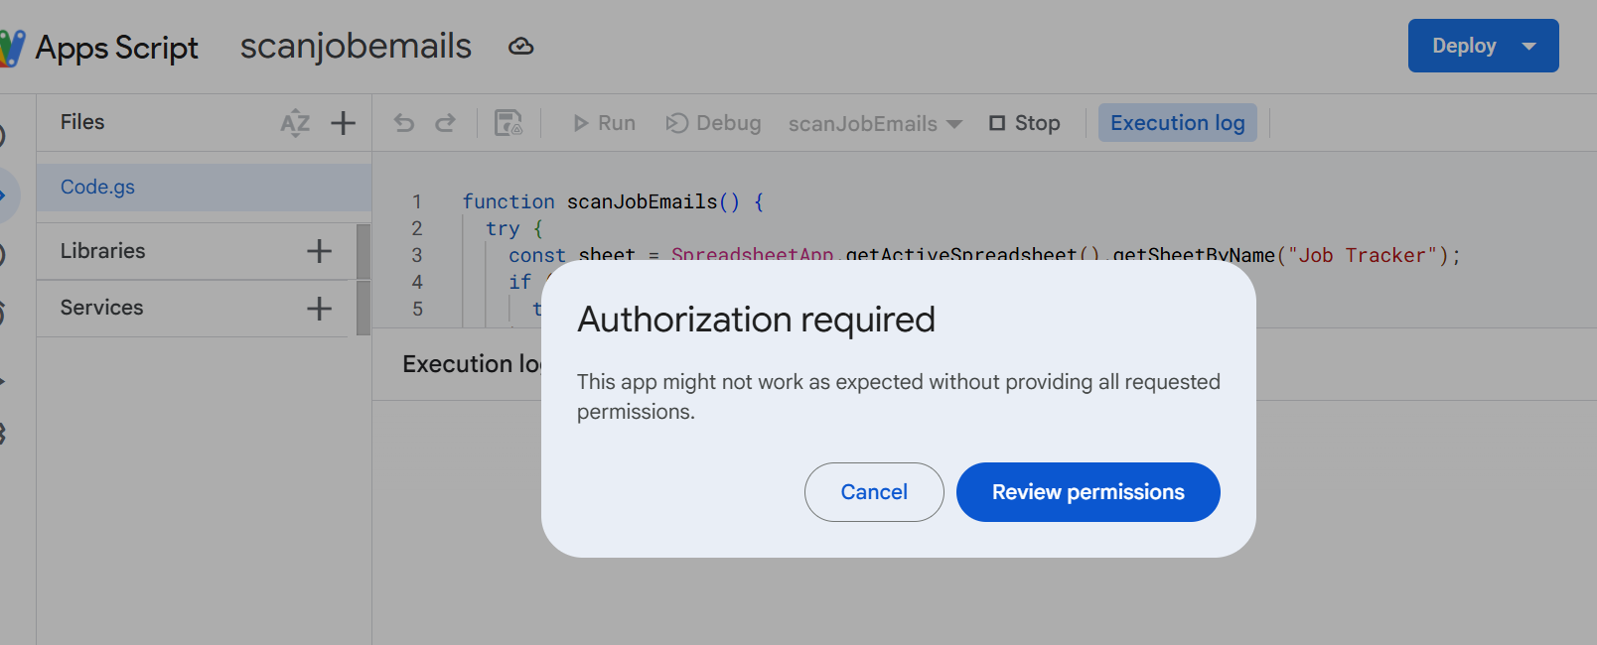
Execution log
10:02:37 PM
Warning
This project requires access to your Google Account to run. Please try again and allow it this time.

Granted the access
Created the sheet – Job Tracker and run the script

Executed successfully
Execution log
10:23:37 PM
Notice
Execution started
10:23:48 PM
Notice
Execution completed
